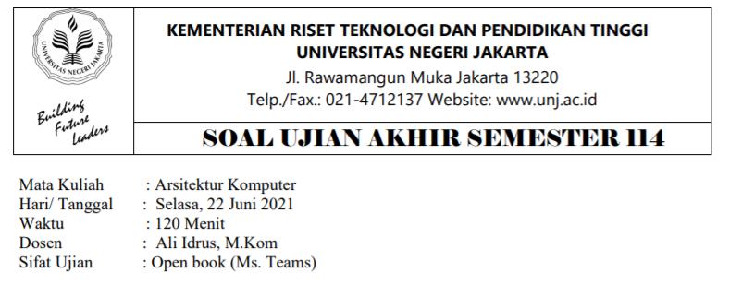

**MAURA QOONITAH PUTRI**

**1313617009**

**ILMU KOMPUTER 2017**

**NOMOR 1.a**

**NOMOR 1.b**

**NOMOR 1.c**

**NOMOR 1.d**

**NOMOR 2**

**NOMOR 3.a,b,c**

**NOMOR 5**

**NOMOR 4**